The Royal School
(Crown Aided)
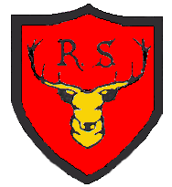

Telephone: 01784 434274
e-mail: theroyalschool@rbwm.org.uk
The Great Park
Windsor, Berkshire. SL4 2HP
Headteacher: Mrs. B. Coombridge

22nd November, 2016
Dear Parents / Carers,

CHRISTMAS LUNCH – WEDNESDAY, 14th DECEMBER, 2016

On Wednesday the 14th December, as is the custom at The Royal School, all the children will sit down together with their teachers to enjoy a Christmas lunch. There will be no packed lunches that day.

A traditional ‘Turkey’ lunch will be served or there will be a vegetarian option of Feta, Spinach and Cranberry Roulade. Please complete and return the attached envelope together with payment of £2.20 by Friday 25th November. If your child has school lunches and you usually pay online please just return the envelope with your child’s meal choice .

Regrettably we are unable to accommodate parents in for lunch on this day, with the exception of the Year 4 mums who have been invited in to help serve the lunch.

Yours sincerely,

Bev Coombridge
Headteacher

