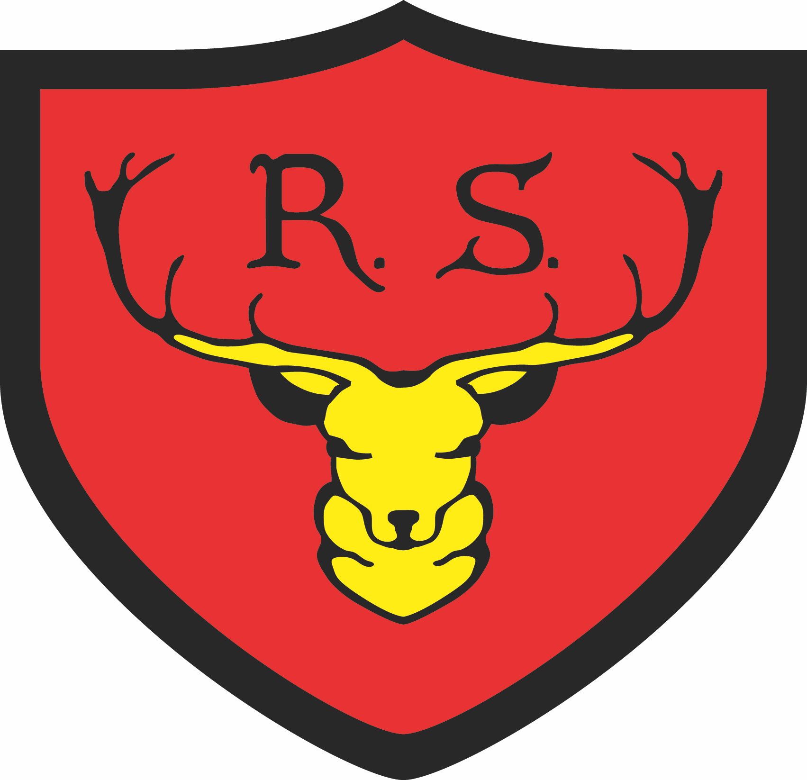

If you are looking for a reception place for your child for September 2025, you are welcome to attend one of our school tours.

Please visit our website for more information about the school.

The Royal School Tour Dates

Tuesday 22nd October 2024 @ 2 pm
Saturday 16th November 2024 @ 10 am
Wednesday 27th November 2024 @ 9.20 am

Please call or email The Royal School Office to book on to one of the above Tour Dates.

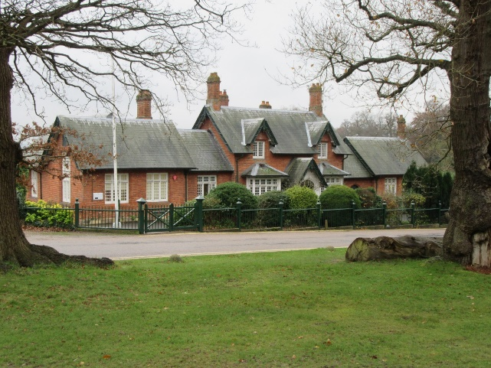

The deadline for applications is: Monday 13th January 2025

The Royal School, The Great Park, Windsor, Berkshire, SL4 2HP.
Email: office@theroyalschool.org.uk Telephone: 01784 434274 Website: www.theroyalschool.org.uk
Headteacher: Mrs Victoria Harrall

